HCI & Computer Graphics Analysis
Tinkercad
Mini Assignment
Name:Yasirr rafique , Roll No: CSE/2K24/157 , Course: HCI & CG
1. HCI Analysis
The following screenshot shows Tinkercad's 3D workspace and its interaction controls.
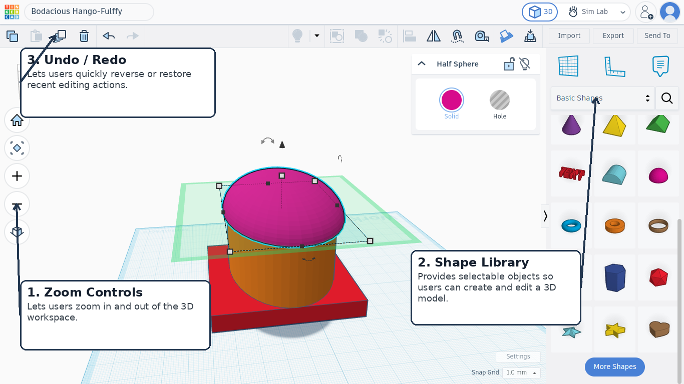
1. Zoom Controls: Lets users zoom in and out of the 3D workspace.
2. Shape Library: Provides selectable objects so users can create and edit a 3D model.
3. Undo / Redo: Lets users quickly reverse or restore recent editing actions.

Computer Graphics Analysis
Tinkercad
Visual/rendering elements that create the 3D experience
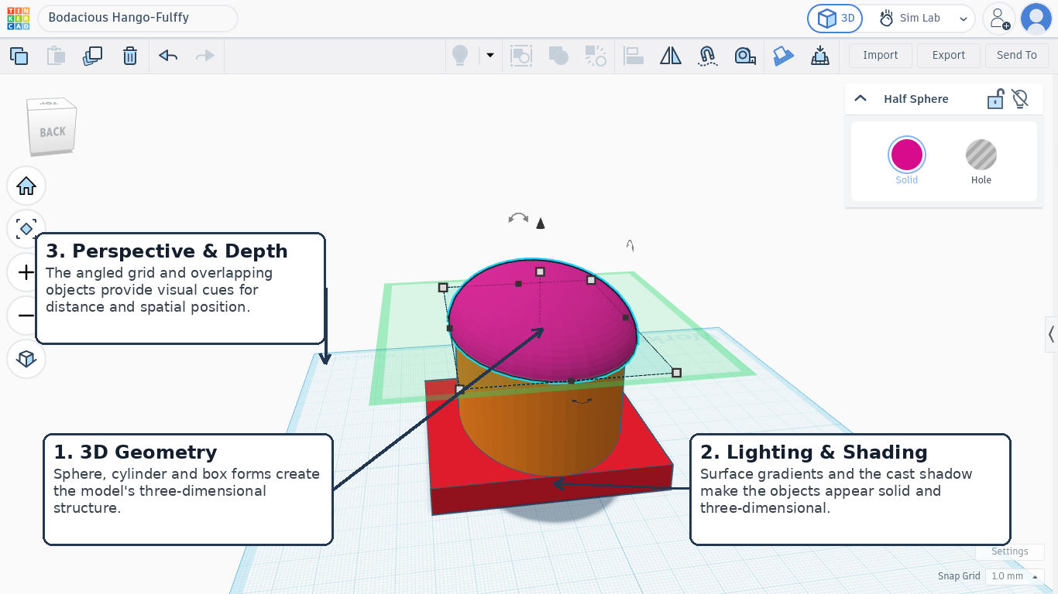
1. 3D Geometry: Sphere, cylinder and box forms create the model's three-dimensional structure.
2. Lighting & Shading: Surface gradients and the cast shadow make the objects appear solid and three-dimensional.
3. Perspective & Depth: The angled grid and overlapping objects provide visual cues for distance and spatial position.
Reflection
1. Good 3D graphics make objects easier to understand because shading, perspective and depth show spatial relationships. Very detailed graphics can also require more processing power.

